|  |  |
| --- | --- |
| Airforce school jamnagar  ACADEMIC YEAR : 2020-21 | **PROJECT ON NOTEPAD USING TKINTER MODULE IN PYTHON**  Tkinter is the standard GUI library for Python. Python when combined with Tkinter provides a fast and easy way to create GUI applications. Tkinter provides a powerful object-oriented interface to the Tk GUI toolkit.  NAME : KIRAN KHER  CLASS : XII-SCIENCE  ROLL NO:  SUBJECT: COMPUTER SCIENCE  PROJECT GUIDE: MRS.AMITA PANDEY |

**Notepad using tkinter through Python**



Certificate

This is to certify that KIRAN KHER student of class XII-SCIENCE has successfully completed the project work entitled NOTEPAD USING TKINTER in the subject of COMPUTER SCIENCE (083) laid down in the regulations of CBSE for the purpose of AISSE(Practical Examination 2020) in Class XII to be held in Airforce School Jamnagar.

MRS.AMITA PANDEY

PGT Comp Sci.

EXAMINER:

NAME:

SIGNATURE:

Acknowledgement

Apart from the efforts of me, the success of any project depends largely on the encouragement and guidelines of many others. I take this opportunity to express my gratitude to the people who have been instrumental in the successful completion of this project.

I express deep sense of gratitude to almighty God for giving me strength for the successful completion of the project.

I express my heartfelt gratitude to my parents for constant encouragement while carrying out this project.

I gratefully acknowledge the contribution of the individuals who contributed in bringing this project up to this level, who continues to look after me despite my flaws,

I express my deep sense of gratitude to the luminary **Mrs.Shubhra Gupta**, Principal Airforce School Jamnagar who has been continuously motivating and extending their helping hand to us.

I am overwhelmed to express my thanks to The Administrative Officer for providing me an infrastructure and moral support while carrying out this project in the school.

My sincere thanks to **Mrs. Amita Pandey.** A guide, Mentor all the above a friend, who critically reviewed my project and helped in solving each and every problem, occurred during implementation of the project

The guidance and support received from all the members who contributed and who are contributing to this project, was vital for the success of the project. I am grateful for their constant support and help.

Table Of Contents

|  |  |  |
| --- | --- | --- |
| **Sr. No.** | **Description** | **Page no.** |
| 1. | INTRODUCTION | 5 |
| 2. | ABOUT TKINTER | 6 |
| 3. | RENDERING A BASIC GUI | 7 |
| 4. | SOURCE CODE | 8 |
| 5. | OUTPUT | 22 |
| 6. | TESTING | 26 |
| 7. | SOFTWARE REQUIREMENTS | 28 |
| 8. | CONCLUSION | 29 |
| 9. | BIBLIOGRAPHY | 30 |

Introduction

What is Python?

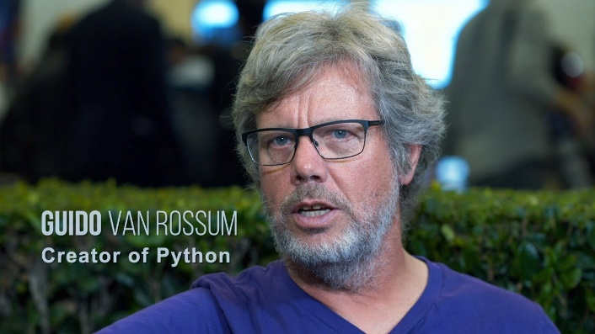Python is a popular programming language. It was created by Guido van Rossum, and released in 1991.

It is used for:

* web development (server-side),
* software development,
* mathematics,
* system scripting.

What can Python do?

* Python can be used on a server to create web applications.
* Python can be used alongside software to create workflows.
* Python can connect to database systems. It can also read and modify files.
* Python can be used to handle big data and perform complex mathematics.
* Python can be used for rapid prototyping, or for production-ready software development.

About Tkinter

Python has a lot of [GUI frameworks](http://wiki.python.org/moin/GuiProgramming), but [Tkinter](https://wiki.python.org/moin/TkInter) is the only framework that’s built into the Python standard library. Tkinter has several strengths. It’s **cross-platform**, so the same code works on Windows, macOS, and Linux. Visual elements are rendered using native operating system elements, so applications built with Tkinter look like they belong on the platform where they’re run.

Although Tkinter is considered the de-facto Python GUI framework, it’s not without criticism. One notable criticism is that GUIs built with Tkinter look outdated. If you want a shiny, modern interface, then Tkinter may not be what you’re looking for.

However, Tkinter is lightweight and relatively painless to use compared to other frameworks. This makes it a compelling choice for building GUI applications in Python, especially for applications where a modern sheen is unnecessary, and the top priority is to build something that’s functional and cross-platform quickly.

Rendering a basic GUI

Source Code

Notepad.py

import tkinter as tk

from tkinter import ttk

from tkinter import font , colorchooser, filedialog, messagebox

import os

main_application = tk.Tk()

main_application.geometry('1200x800')

main_application.title('Notepad')

main_application.wm_iconbitmap('mainicon.ico')

########## main menu #############

main_menu = tk.Menu()

#File icons

new_icon =tk.PhotoImage(file='icons2/new.png')

open_icon =tk.PhotoImage(file='icons2/open.png')

save_icon =tk.PhotoImage(file='icons2/save.png')

save_as_icon =tk.PhotoImage(file='icons2/save_as.png')

exit_icon = tk.PhotoImage(file='icons2/exit.png')

file = tk.Menu(main_menu,tearoff=False)

####edit

#edit icons

copy_icon = tk.PhotoImage(file='icons2/copy.png')

paste_icon = tk.PhotoImage(file='icons2/paste.png')

cut_icon = tk.PhotoImage(file='icons2/cut.png')

clear_all_icon = tk.PhotoImage(file='icons2/clear_all.png')

find_icon = tk.PhotoImage(file='icons2/find.png')

edit= tk.Menu(main_menu,tearoff=False)

##commands are added after edit menu

####view

#view icons

tool_bar_icon = tk.PhotoImage(file='icons2/tool_bar.png')

status_bar_icon = tk.PhotoImage(file='icons2/status_bar.png')

view = tk.Menu(main_menu,tearoff=False)

###color theme

light_default_icon=tk.PhotoImage(file='icons2/light_default.png')

light_plus_icon=tk.PhotoImage(file='icons2/light_plus.png')

dark_icon=tk.PhotoImage(file='icons2/dark.png')

red_icon=tk.PhotoImage(file='icons2/red.png')

monokai_icon=tk.PhotoImage(file='icons2/monokai.png')

night_blue_icon=tk.PhotoImage(file='icons2/night_blue.png')

color_theme = tk.Menu(main_menu,tearoff=False)

#all icons saved in a tuple

theme_choice = tk.StringVar()

color_icons = (light_default_icon ,light_plus_icon,dark_icon,red_icon,monokai_icon,night_blue_icon)

## text ,background

#

color_dict = {

'Light Default' :('#000000','fffffff'),

'Light Plus' :('#474747','#e0e0e0'),

'Dark' : ('#c4c4c4', '#2d2d2d'),

'Red' : ('#2d2d2d','#ffe8e8'),

'Monokai' : ('#d3b774','#474747'),

'Night Blue' :('#ededed','#6b9dc2')

}

# cascade

main_menu.add_cascade(label='File',menu=file)

main_menu.add_cascade(label='Edit',menu=edit)

main_menu.add_cascade(label='View',menu=view)

main_menu.add_cascade(label='Color Theme',menu=color_theme)

#----------&&&&& End main menu &&&&&----------#

########## toolbar #############

tool_bar = ttk.Label(main_application)

tool_bar.pack(side=tk.TOP,fill=tk.X)

##font box

font_tuple = tk.font.families()

font_family = tk.StringVar()

font_box=ttk.Combobox(tool_bar, width=30 ,textvariable=font_family,state='readonly' )

font_box['values']=font_tuple

font_box.current(font_tuple.index('Arial'))

font_box.grid(row=0,column=0,padx=5)

##size box

size_var = tk.IntVar()

font_size=ttk.Combobox(tool_bar,width=14,textvariable = size_var,state='readonly')

font_size['values']=tuple(range(8,80,2))

font_size.current(4)

font_size.grid(row=0,column=1,padx=5)

##bold button

bold_icon = tk.PhotoImage(file='icons2/bold.png')

bold_btn =ttk.Button(tool_bar ,image=bold_icon)

bold_btn.grid(row=0, column=2, padx=5)

##italic button

italic_icon = tk.PhotoImage(file='icons2/italic.png')

italic_btn=ttk.Button(tool_bar,image=italic_icon)

italic_btn.grid(row=0, column=3,padx=5)

##underline button

underline_icon = tk.PhotoImage(file='icons2/underline.png')

underline_btn=ttk.Button(tool_bar,image=underline_icon)

underline_btn.grid(row=0, column=4,padx=5)

##font color button

font_icon = tk.PhotoImage(file='icons2/font_color.png')

font_color_btn = ttk.Button(tool_bar,image=font_icon)

font_color_btn.grid(row=0, column=5,padx=5)

## align_left

align_left_icon = tk.PhotoImage(file='icons2/align_left.png')

align_left_btn=ttk.Button(tool_bar,image=align_left_icon)

align_left_btn.grid(row=0,column=6,padx=5)

##align center

align_center_icon = tk.PhotoImage(file='icons2/align_center.png')

align_center_btn= ttk.Button(tool_bar,image=align_center_icon)

align_center_btn.grid(row=0,column=7,padx=5)

##align right

align_right_icon = tk.PhotoImage(file='icons2/align_right.png')

align_right_btn=ttk.Button(tool_bar,image=align_right_icon)

align_right_btn.grid(row=0,column=8,padx=5)

#----------&&&&& End toolbar &&&&&----------#

########## text editor #############

text_editor = tk.Text(main_application)

text_editor.config(wrap = 'word', relief=tk.FLAT)

scroll_bar = tk.Scrollbar(main_application)

text_editor.focus_set()

scroll_bar.pack(side = tk.RIGHT,fill=tk.Y)

text_editor.pack(fill=tk.BOTH, expand=True)

scroll_bar.config(command=text_editor.yview)

text_editor.config(yscrollcommand= scroll_bar.set)

## font family and font size functionality

current_font_family= 'Arial'

current_font_size= 12

def change_font(event=None):

global current_font_family

current_font_family = font_family.get()

text_editor.config(font=(current_font_family,current_font_size))

def change_size(event=None):

global current_font_size

current_font_size = size_var.get()

text_editor.config(font=(current_font_family,current_font_size))

##binding combobox with function

font_box.bind("<<ComboboxSelected>>",change_font)

font_size.bind("<<ComboboxSelected>>",change_size)

####### buttons functionality

#bold buttton functionality

def change_bold():

text_property=tk.font.Font(font=text_editor['font'])

##upper line gives a dictionary whose attributes we are changing

if text_property.actual()['weight']=='normal' :

text_editor.configure(font=(current_font_family,current_font_size,'bold'))

if text_property.actual()['weight']=='bold' :

text_editor.configure(font=(current_font_family,current_font_size,'normal'))

bold_btn.configure(command=change_bold)

#italic button functionality

def change_italic():

text_property=tk.font.Font(font=text_editor['font'])

##upper line gives a dictionary whose attributes we are changing

if text_property.actual()['slant']=='roman' :

text_editor.configure(font=(current_font_family,current_font_size,'italic'))

if text_property.actual()['slant']=='italic' :

text_editor.configure(font=(current_font_family,current_font_size,'normal'))

italic_btn.configure(command=change_italic)

##underline button functionality

def underline():

text_property=tk.font.Font(font=text_editor['font'])

##upper line gives a dictionary whose attributes we are changing

if text_property.actual()['underline']==0 :

text_editor.configure(font=(current_font_family,current_font_size,'underline'))

if text_property.actual()['underline']==1 :

text_editor.configure(font=(current_font_family,current_font_size,'normal'))

underline_btn.configure(command=underline)

##font color functionality

def change_font_color():

color_var = tk.colorchooser.askcolor()

##ask color asks for a color and stores into the color_var

##text color is called foreground color also abbrivated as fg

## a tuple in which 0th ondex shows the RGB values where as 1st index shows hexa value for color

text_editor.configure(fg=color_var[1])

font_color_btn.configure(command=change_font_color)

### align functionality

def align_left():

text_content = text_editor.get(1.0, 'end')

text_editor.tag_config('left',justify=tk.LEFT)

text_editor.delete(1.0,tk.END)

text_editor.insert(tk.INSERT,text_content,'left')

align_left_btn.configure(command=align_left)

###align center

def align_center():

text_content = text_editor.get(1.0, 'end')

text_editor.tag_config('center',justify=tk.CENTER)

text_editor.delete(1.0,tk.END)

text_editor.insert(tk.INSERT,text_content,'center')

align_center_btn.configure(command=align_center)

##align right

def align_right():

text_content = text_editor.get(1.0, 'end')

text_editor.tag_config('right',justify=tk.RIGHT)

text_editor.delete(1.0,tk.END)

text_editor.insert(tk.INSERT,text_content,'right')

align_right_btn.configure(command=align_right)

text_editor.configure(font=('Arial',12))

#----------&&&&& End text editor &&&&&----------#

######### status bar #############

status_bar = ttk.Label(main_application, text ='Status Bar')

status_bar.pack(side=tk.BOTTOM)

text_changed = False

def changed(event=None):

global text_changed

if text_editor.edit_modified():###checks if any character is added or not

text_changed= True

words = len(text_editor.get(1.0, 'end-1c').split()) ##it even counts new line character so end-1c subtracts one char

characters = len(text_editor.get(1.0,'end-1c'))

status_bar.config(text=f' Words: {words} Characters : {characters}')

text_editor.edit_modified(False)

text_editor.bind('<<Modified>>',changed)

#----------&&&&& End main status bar &&&&&----------#

########## main menu functinality #############

##file commands

##variable

url = ''

##new functionality

def new_file(event=None):

global url

url = ''

text_editor.delete(1.0,tk.END)

file.add_command(label='new', image=new_icon ,compound=tk.LEFT, accelerator ='Ctrl+N',command=new_file )

##open functionality

## it is coppying the data from the desired file into the working file

def open_file(event=None):

global url

url = filedialog.askopenfilename(initialdir= os.getcwd(), title ='Select File',filetypes=(('Text File','*.txt'),('All files','*.*')))

try:

with open(url, 'r') as fr:

text_editor.delete(1.0,tk.END)

text_editor.insert(1.0,fr.read())

except FileNotFoundError:

return

except :

return

main_application.title(os.path.basename(url))

file.add_command(label='Open', image=open_icon ,compound=tk.LEFT, accelerator ='Ctrl+O',command =open_file )

##save functionality

def save_file(event=None):

global url

try:

if url :

content = str(text_editor.get(1.0,tk.END))

with open(url,'w',encoding= 'utf-8') as fw:

fw.write(content)

else :

url = filedialog.asksaveasfile(mode = 'w' ,defaultextension = '.txt',filetypes=(('Text File','*.txt'),('All files','*.*')))

content = text_editor.get(1.0,tk.END)

url.write(content)

url.close()

except :

return

file.add_command(label='Save', image=save_icon ,compound=tk.LEFT, accelerator ='Ctrl+S',command= save_file )

###save as functionality

def save_as(event=None):

global url

try :

content=text_editor.get(1.0,tk.END)

url = filedialog.asksaveasfile(mode = 'w' ,defaultextension = '.txt',filetypes=(('Text File','*.txt'),('All files','*.*')))

url.write(content)

url.close

except :

return

file.add_command(label='Save As', image=save_as_icon ,compound=tk.LEFT, accelerator ='Ctrl+Alt+S',command =save_as )

##exit functionality

def exit_func(event=None):

global url, text_changed

try:

if text_changed:

mbox = messagebox.askyesnocancel('Warning','Do you want to save the file')

if mbox is True :

##if user wants to save the file and it already exists

if url:

content = text_editor.get(1.0,tk.END)

with open(url,'w',encoding='utf-8') as fw:

fw.write(content)

main_application.destroy()

else:

content2 = str(text_editor.get(1.0,tk.END))

url = filedialog.asksaveasfile(mode = 'w' ,defaultextension = '.txt',filetypes=(('Text File','*.txt'),('All files','*.*')))

url.write(content2)

url.close()

main_application.destroy()

elif mbox is False:

main_application.destroy()

else:

main_application.destroy()

except:

return

file.add_command(label='Exit', image=exit_icon ,compound=tk.LEFT, accelerator ='Ctrl+Q',command=exit_func )

###edit commands

### find functionality

def find_func(event=None):

##using tag inbuilt function

def find():

word = find_input.get()

text_editor.tag_remove('match','1.0',tk.END)

matches = 0

if word :

start_pos = '1.0'

while True :

start_pos = text_editor.search(word,start_pos,stopindex=tk.END)

if(not start_pos):

break

end_pos = f'{start_pos}+{len(word)}c'

text_editor.tag_add('match',start_pos,end_pos)

matches +=1

start_pos=end_pos

text_editor.tag_config('match',foreground='red',background='')

def replace():

word = find_input.get()

replace_text = replace_input.get()

content = text_editor.get(1.0,tk.END)

new_content = content.replace(word,replace_text)

text_editor.delete(1.0,tk.END)

text_editor.insert(1.0,new_content)

find_dialogue = tk.Toplevel()

find_dialogue.geometry('450x250+500+200')

find_dialogue.resizable(0,0)

## frame

find_frame = ttk.LabelFrame(find_dialogue, text ='Find/Replace')

find_frame.pack(pady=20)

## labels

text_find_label = ttk.Label(find_frame,text ='Find :')

text_replace_label = ttk.Label(find_frame,text ='Replace')

##entry boxes

find_input = ttk.Entry(find_frame,width=30)

replace_input = ttk.Entry(find_frame,width=30)

## Button

find_button = ttk.Button(find_frame,text ='Find',command=find)

replace_button =ttk.Button(find_frame,text='Replace',command=replace)

##label grid

text_find_label.grid(row=0,column=0,padx=4,pady=4)

text_replace_label.grid(row=1,column=0,padx=4,pady=4)

##entry grid

find_input.grid(row=0, column=1,padx=4,pady=4)

replace_input.grid(row=1, column=1,padx=4,pady=4)

##button grid

find_button.grid(row=2 ,column=0 ,padx=8,pady=4)

replace_button.grid(row=2 ,column=1 ,padx=8,pady=4)

find_dialogue.mainloop()

edit.add_command(label='Copy',image=copy_icon,compound=tk.LEFT, accelerator='Ctrl+C',command=lambda:text_editor.event_generate("<Control c>"))

edit.add_command(label='Paste',image=paste_icon,compound=tk.LEFT, accelerator='Ctrl+V',command=lambda:text_editor.event_generate("<Control v>"))

edit.add_command(label='Cut',image=cut_icon,compound=tk.LEFT, accelerator='Ctrl+X',command=lambda:text_editor.event_generate("<Control x>"))

edit.add_command(label='Clear All',image=clear_all_icon,compound=tk.LEFT, accelerator='Ctrl+ALt+X',command=lambda:text_editor.delete(1.0,tk.END))

edit.add_command(label='Find',image=find_icon,compound=tk.LEFT, accelerator='Ctrl+F',command=find_func)

#view check button

##it will have check button

show_statusbar = tk.BooleanVar()

show_statusbar.set(True)

show_toolbar = tk.BooleanVar()

show_toolbar.set(True)

def hide_toolbar():

global show_toolbar

if show_toolbar:

tool_bar.pack_forget()

show_toolbar =False

else:

text_editor.pack_forget()

status_bar.pack_forget()

tool_bar.pack(side=tk.TOP,fill=tk.X)

text_editor.pack(fill=tk.BOTH,expand =True)

status_bar.pack(side=tk.BOTTOM)

show_toolbar = True

def hide_statusbar():

global show_statusbar

if show_statusbar:

status_bar.pack_forget()

show_statusbar =False

else:

status_bar.pack(side=tk.BOTTOM)

show_statusbar=True

view.add_checkbutton(label='Tool Bar',onvalue =True,offvalue=0,variable =show_toolbar,image=tool_bar_icon, compound=tk.LEFT,command=hide_toolbar)

view.add_checkbutton(label='Status Bar',onvalue =1,offvalue=False,variable =show_statusbar,image=status_bar_icon, compound=tk.LEFT,command=hide_statusbar)

###color theme

def change_theme():

choose_theme = theme_choice.get()

color_tuple =color_dict.get(choose_theme)

fg_color,bg_color =color_tuple[0], color_tuple[1]

text_editor.config(background=bg_color,fg=fg_color)

count = 0

for i in color_dict :

color_theme.add_radiobutton(label = i,image=color_icons[count],variable=theme_choice,compound=tk.LEFT,command =change_theme)

count+=1

#----------&&&&& End main menu functinality &&&&&----------#

##bind shortcut keys

main_application.bind("<Control-n>", new_file)

main_application.bind("<Control-o>", open_file)

main_application.bind("<Control-s>", save_file)

main_application.bind("<Control-Alt-s>", save_as)

main_application.bind("<Control-q>", exit_func)

main_application.bind("<Control-q>", exit_func)

main_application.bind("<Control-f>", find_func)

main_application.config(menu=main_menu)

main_application.mainloop()

setup.py

import cx_Freeze

import sys

import os

base = None

if sys.platform == 'win32':

base = "Win32GUI"

os.environ['TCL_LIBRARY'] = r"C:\Users\MAUT\AppData\Local\Programs\Python\Python37\tcl\tcl8.6"

os.environ['TK_LIBRARY'] = r"C:\Users\MAUT\AppData\Local\Programs\Python\Python37\tcl\tk8.6"

executables = [cx_Freeze.Executable("Notepad.py", base=base, icon="mainicon.ico")]

cx_Freeze.setup(

name = " Notepad ",

options = {"build_exe": {"packages":["tkinter","os"], "include_files":["mainicon.ico",'tcl86t.dll','tk86t.dll', 'icons2']}},

version = "0.01",

description = "Tkinter Application",

executables = executables

)

Output

* Notepad

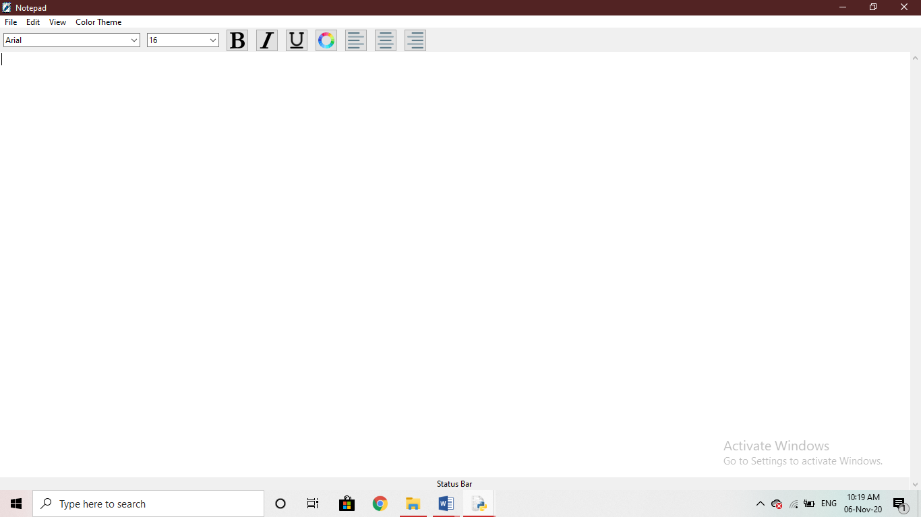

* Fonts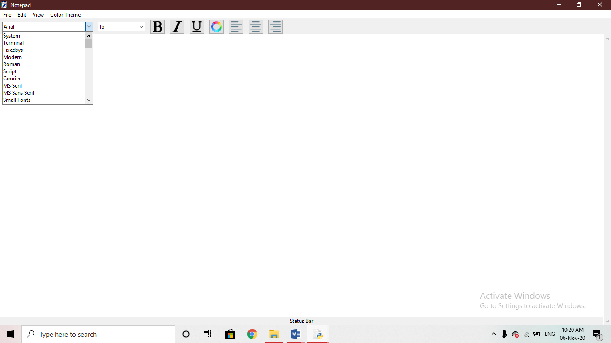
* Font Size

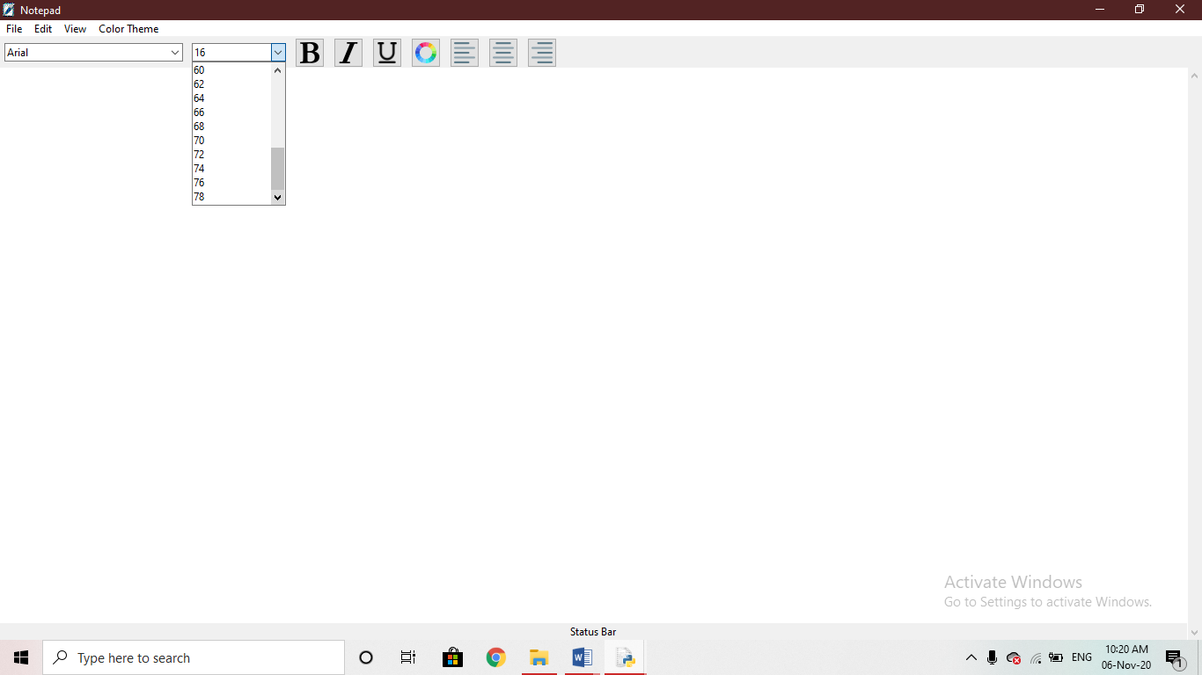

* Font Colour

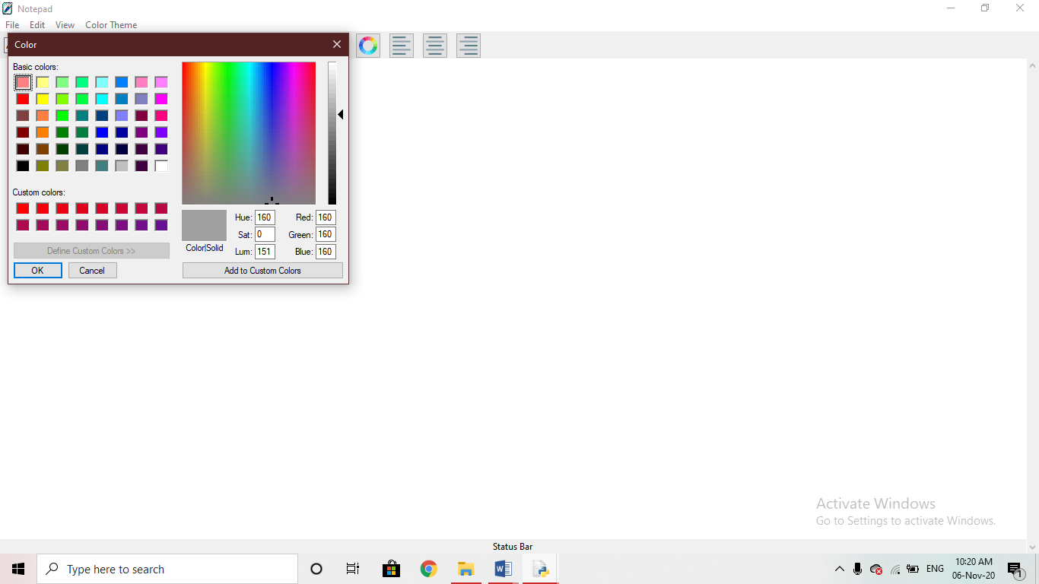

* Themes

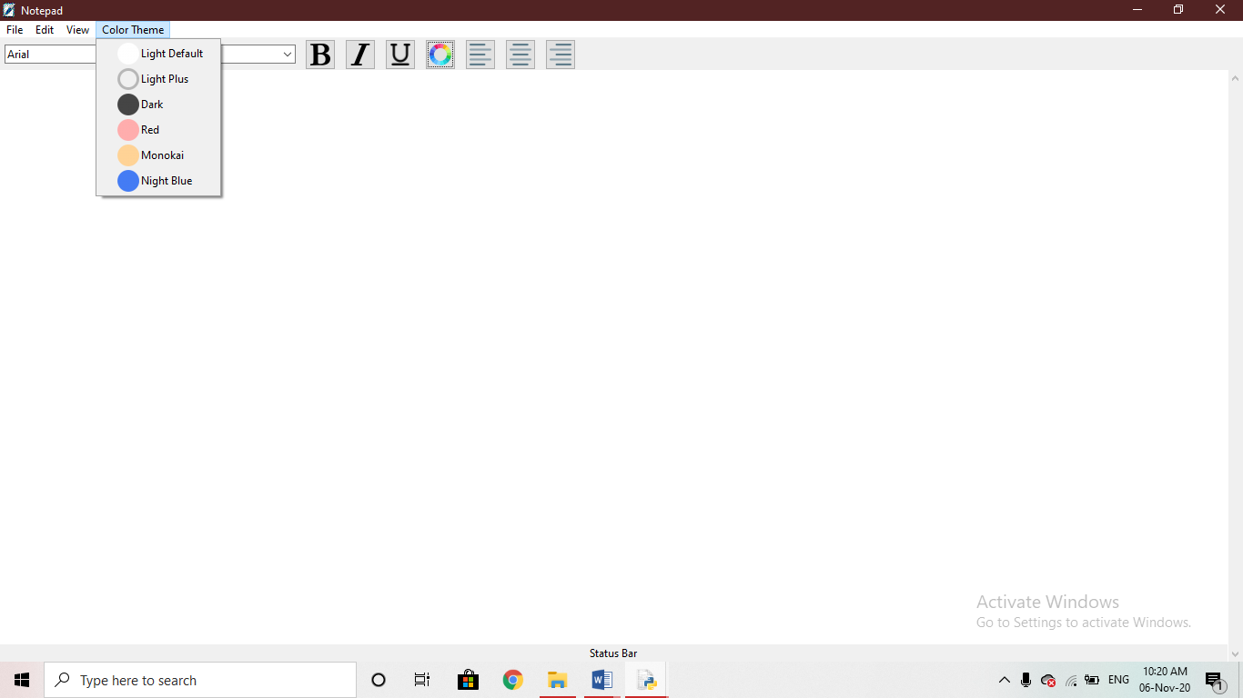

* Toolbars

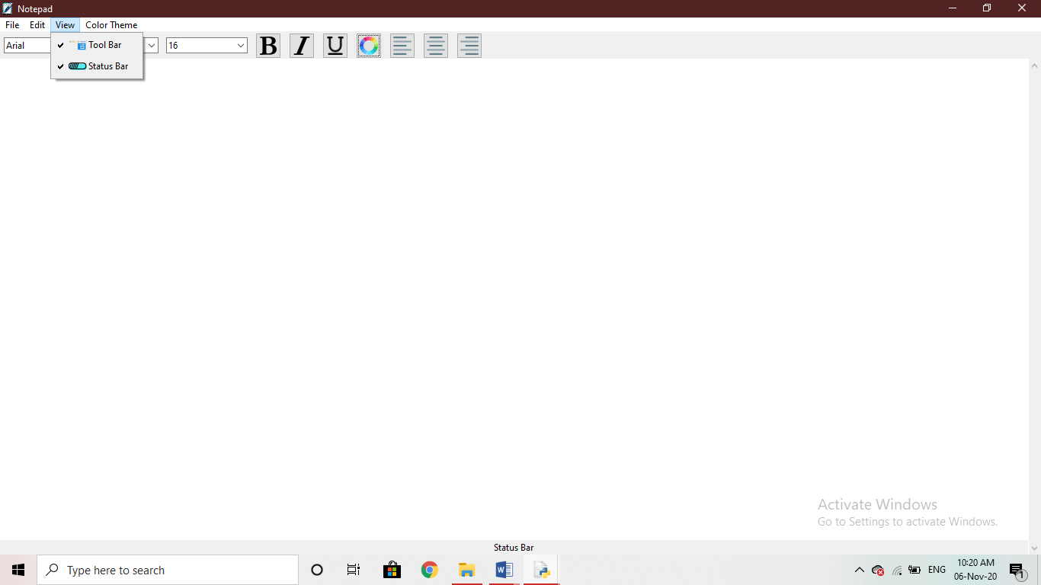

* Edit

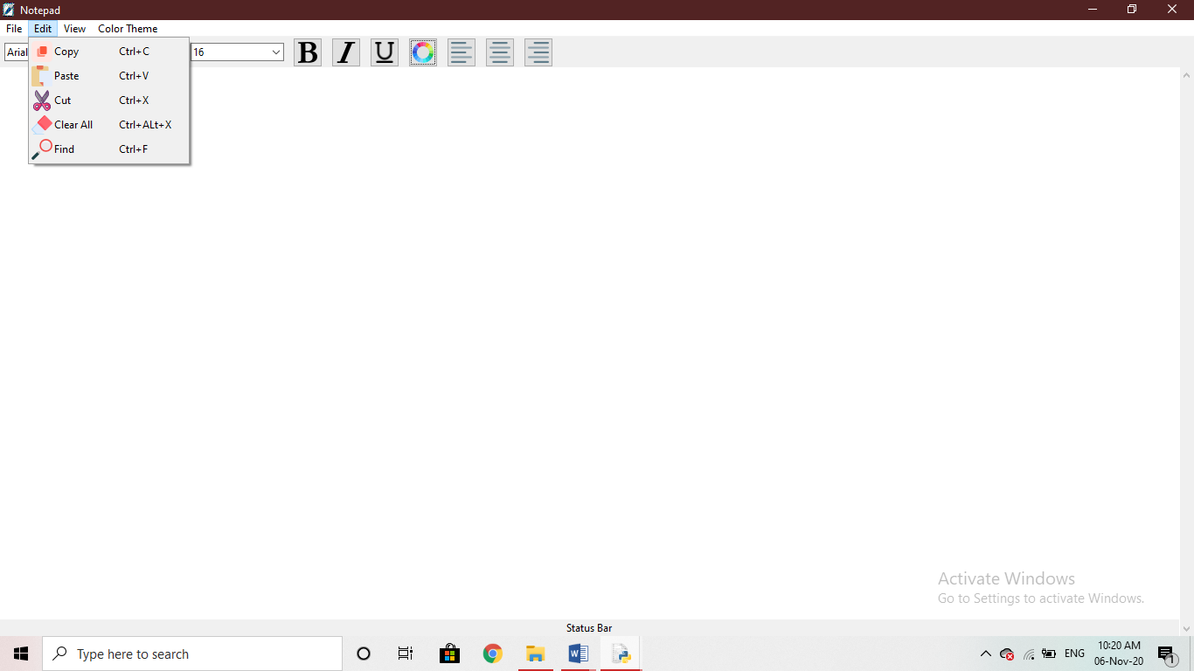

* Files

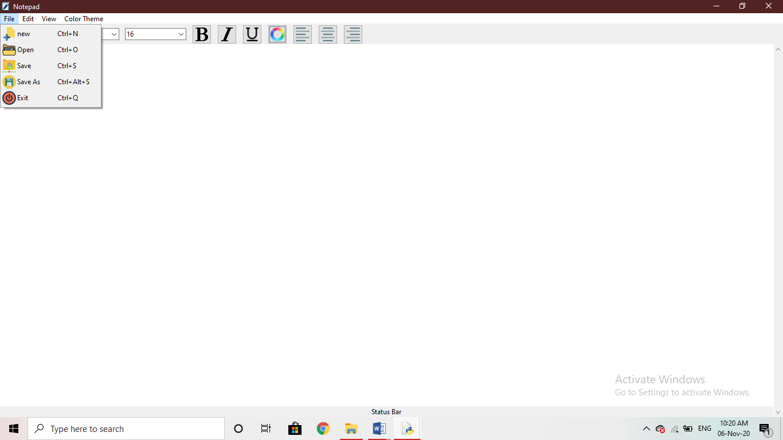

Testing

* Changing Font Style

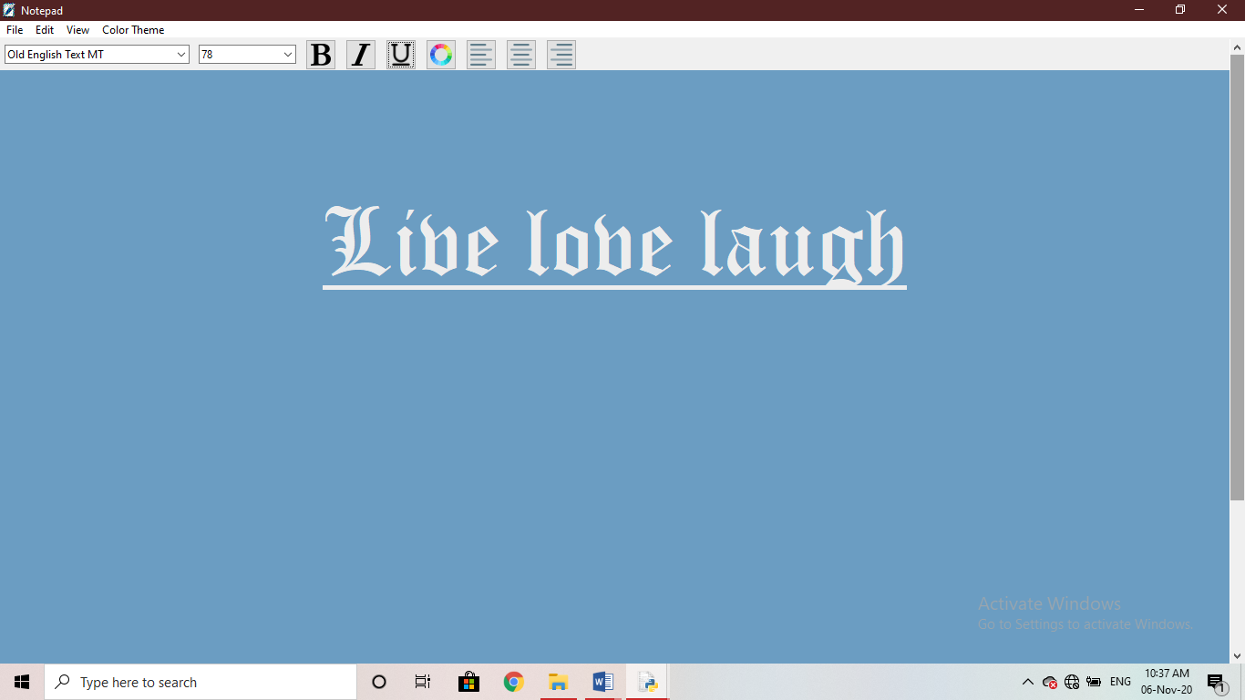

* Changed Theme

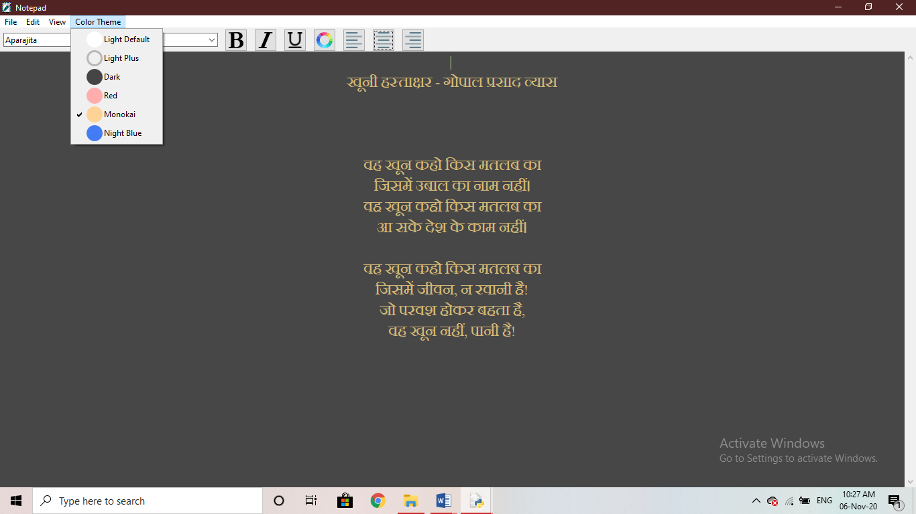

* Find And Replace

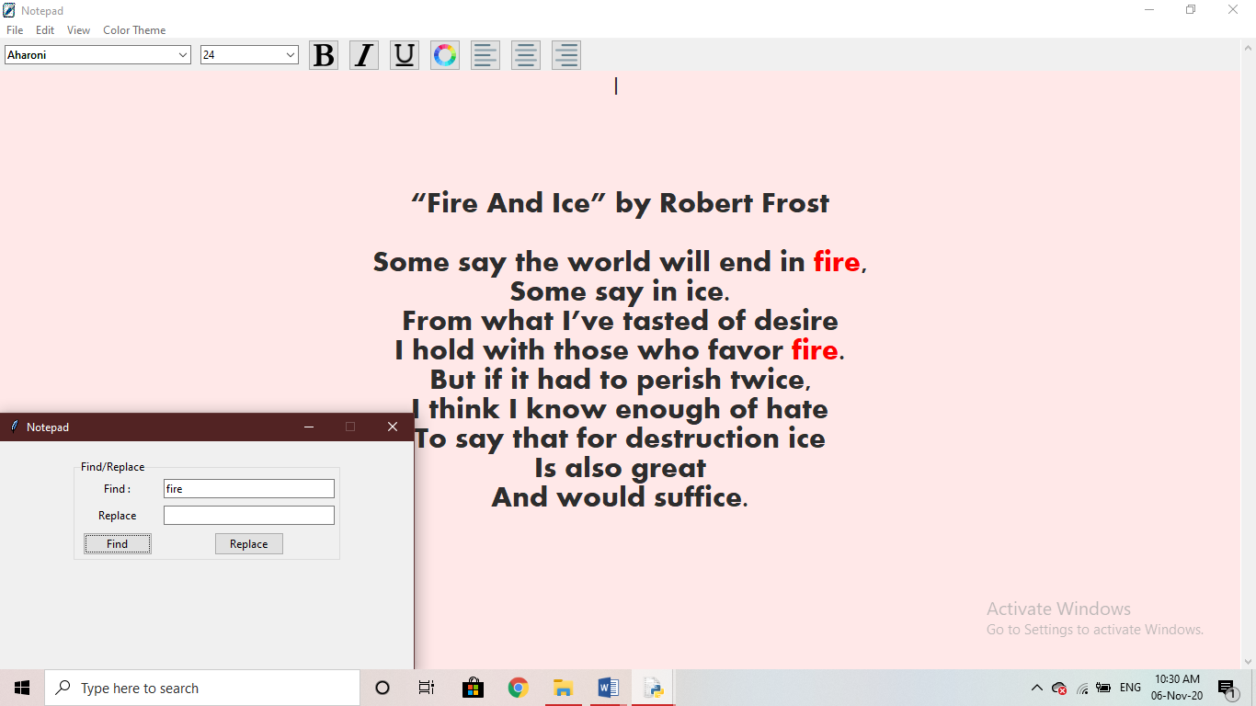

* Saving a File

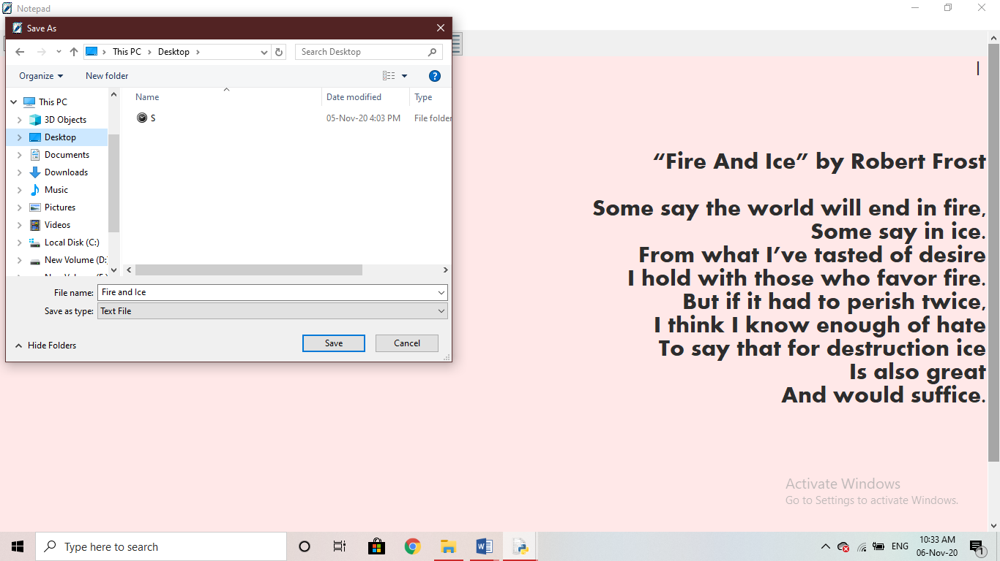

C

Software Requirements

* Windows OS
* Python IDLE/Spyder/Pycharm
* Files Attached;

1. mainicon 
2. icons2

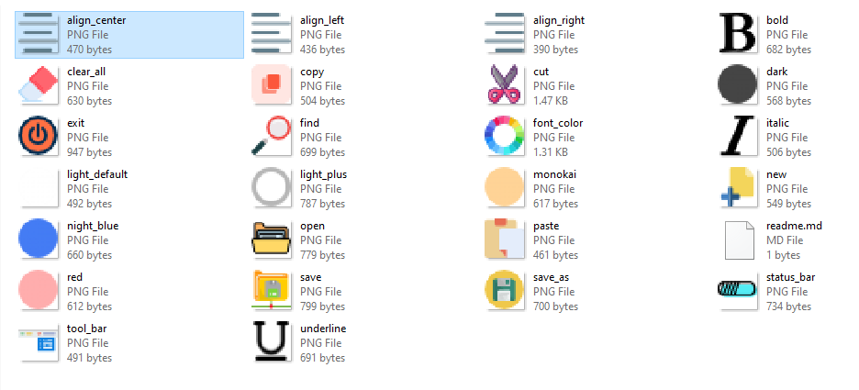

Conclusion

Here, using tkinter I have created a notepad like text editor. This notepad will have the menu where we can create new file, open existing file, save the file, editing, cut and paste, all functionality will be there. I have also added the function to change the themes or the background of the text editor and simultaneously we can also change the foreground as well. This small program has helped me enhance my knowledge on the python GUI modules and surely proved to be helpful in future.

Bibliography

* Referrences taken from;
* Computer Science with Python Textbook of class XI: Preeti Arora
* Computer Science with Python Textbook of class XII: Sumita Arora
* Computer Science with Python Textbook of class XII: Preeti Arora
* Websites:

1. <https://docs.python.org/3/library/tkinter.html>
2. <https://wiki.python.org/moin/TkInter>
3. <https://wiki.python.org/moin/TkInter>